Jeremy Maniago

PHYS 454

Professor Hedberg

HW#3

# Paper Spectrometer

To be able to obtain spectral emission lines of different light sources, we need to craft a DIY paper spectrometer. **Figure 1** shows one built with a special paper to avoid noise from light sources not being analyzed and to prevent unnecessary reflections. It consists of a part of a CD and a slit at the other end.

# Compact Fluorescent Bulb Spectrum

**Figure 2** shows an image taken with the spectrometer of a compact fluorescent (CF) bulb. In this image, the x and y axes are in terms of pixels, which is a grid 3072x4080 pixels and is how large the image matrix is.

Figure 1: Paper Spectrometer

Figure 2: Spectrometer image of CF bulb taken with a Google Pixel 6 camera

**Figure 3** shows the image rotated 90 degrees counterclockwise and the corresponding Red, Blue, and Green (RGB) spectrum, which is plotted with respect to their pixel position and the relative intensities of each color. In preparation for (RGB) spectrum analysis, a line is drawn across the image where the average of all the RGB intensities can be extracted from. **Figure 4** shows the average value spectrum plot.

Figure 3: RGB Spectrum for CF Bulb

Figure 4: Average RGB Spectrum for CF Bulb

Based on given calibration values, the average spectrum was calibrated to convert the pixel positions into wavelengths, with peaks corresponding to the colors and their wavelengths. **Figure 5** shows the final calibrated CF bulb spectrum.

Figure 5: Calibrated CF spectrum

# Mystery Tube

The same steps for converting the CF bulb image into a spectrum will be followed for finding the Mystery Tube spectrum. **Figure 6** shows the image taken with the paper spectrometer of the Mystery Tube.

Figure 6: Spectrometer image of Mystery Tube taken with a Google Pixel 6 camera

**Figure 7** shows the Mystery Tube’s RGB spectrum, with the CF spectrum below for reference. It is crucial that the images were taken within a close time frame to ensure that the camera’s position relative to the spectrometer did not change. This will allow us to super-impose the Mystery Tube spectrum onto the CF one without need for calibration. **Figure 8** shows the calibrated Mystery Tube spectrum, which was calibrated based on the CF spectrum parameters.

Figure 7: RGB Spectrum for Mystery Tube

Figure 8: Average RGB Spectrum for Mystery Tube

**Figure 9** shows the Mystery Tube spectrum plotted with the CF spectrum. From here, we can obtain the peaks of the Mystery Tube spectrum and match them to their respective color, shown in **Table 1**.

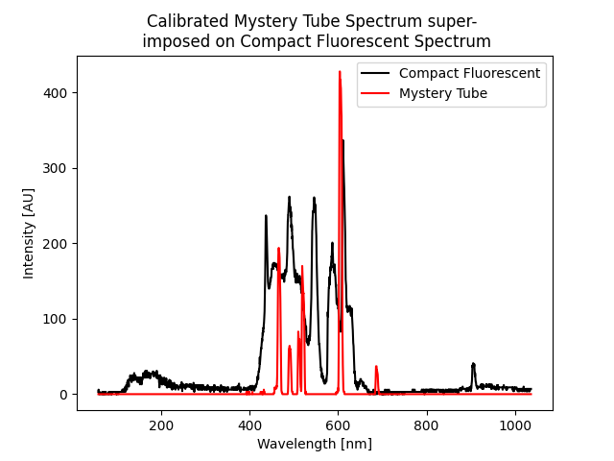

Figure 9: CF bulb and Mystery Tube spectrum

|  |  |
| --- | --- |
| Mystery Tube Spectrum Peaks | |
| Wavelength [nm] | Color |
| 465.626 | Blue/Violet |
| 518.652 | Green |
| 603.590 | Red/Yellow |

Table 1: Peak wavelengths and corresponding colors of Mystery Tube spectrum

According to these peak wavelengths, it was predicted that the mystery gas was **Helium**. This was based on comparing the wavelengths that Helium emits, as well as their relative intensity [1].

# Spectrometer Images and Spectra for two other sources

1. Refrigerator Bulb

Figure 11: Spectrometer image of Refrigerator Bulb taken with a Google Pixel 6 camera

Figure 10: RGB and average RGB Spectrum for Refrigerator Bulb

1. Hallway Bulb

Figure 13: Spectrometer image of Hallway Bulb taken with a Google Pixel 6 camera

Figure 12: RGB and average RGB Spectrum for Hallway Bulb

# References

[1] [rydberg.pdf (utoronto.ca)](https://www.physics.utoronto.ca/~phy293lab/experiments/rydberg.pdf), pdf page 7 of 10

[2] Source Code –

<https://colab.research.google.com/drive/1kFnWMAuHo-ikZmXnuzusWM8Nsl_xS8J7?usp=sharing>